**Task: *Testing the ‘Register account’ page***

Execution Date: Short Description: Test the ATM Change PIN service

|  |  |
| --- | --- |
| Test Case #: 1 | Test Case Name: Validate Register account |
| System: On the Spot (website) | System: Register Subsystem |
| Designed by: Roslin Punnoose | Designed date: 17/04/2016 |
| Executed by: Joshua Russell-Ahern | Executed date: 20/06/2016 |
| Short Description: Test the validation for the “Register account page.” | |

**Pre conditions:**

* User decides to create an account (as they don’t have one)
* User has a valid email address.
* User has contact number and address
* Initially the “On the spot” main page is displayed.

|  |  |  |  |  |
| --- | --- | --- | --- | --- |
| Step | Action | Expected System Response | Pass/ Fail | Comment |
| 1. | Entered “roslinpunnoose” as email address. | The website coming up with a *hidden message* telling “Please include an ‘@” in the mail address. | P | This helps the user to re-enter the correct details. |
| 2. | Enter 8 digit- contact number instead of 10 “04040404” | The digits entered in the Contact number tab is “red in color” (not valid number) | P | This helps the customer to re-enter the correct no: |
| 3. | Entered the Suburb name “Herston” | The system automatically comes up **(API geocode)** with the state, postcode and country name along with the suburb. | P | This reduce the efforts of the user to type the whole address |
| 4. | Clicked the Submit button | Check through all the tabs. Looks whether the info is valid, any info is missing.  Navigate to the Main menu page | P | User can once again verify before submitting it. |

**Pre conditions:**

* User has created an account with valid customer details in the “On the Spot” website.
* User then able to navigate to the Main menu page (to start the order)

Below is the screenshot of the above testing

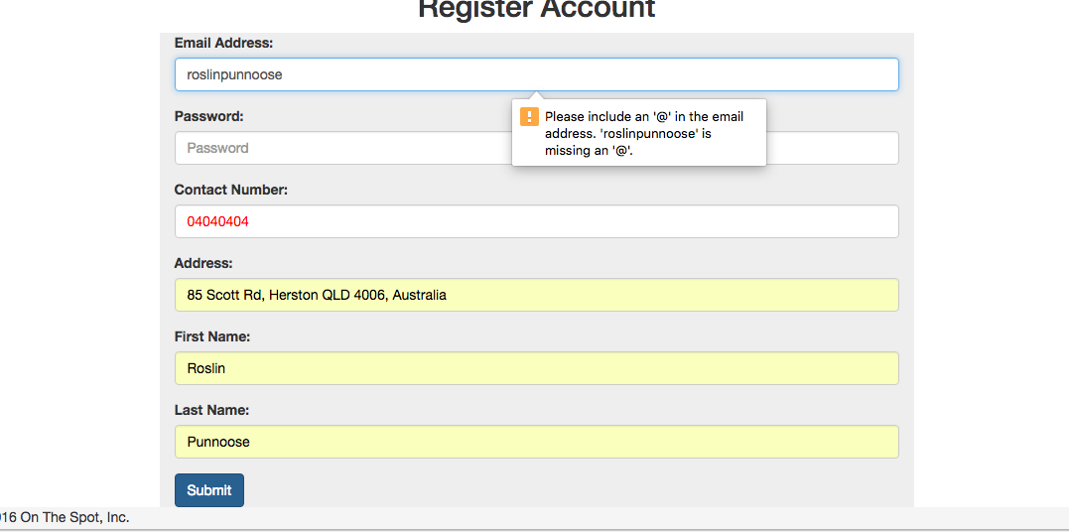

The beneficial for testing this is described in the portfolio document.